We followed the following guidelines:

Front two wheel need to be steerable. Make sure both the wheels steer independently.

• Full length of chassis (Longitudinal) - 38 inches.

• Breadth of chassis (Lateral) - 20 inches.

• Wheelbase - 20 inches.

• Wheel thickness - 3 inches.

• Wheel diameter - 8 inches.

The only difference is that we used mm-s instead of inches.

The wheel was created using extrude and two cuts from the two sides.

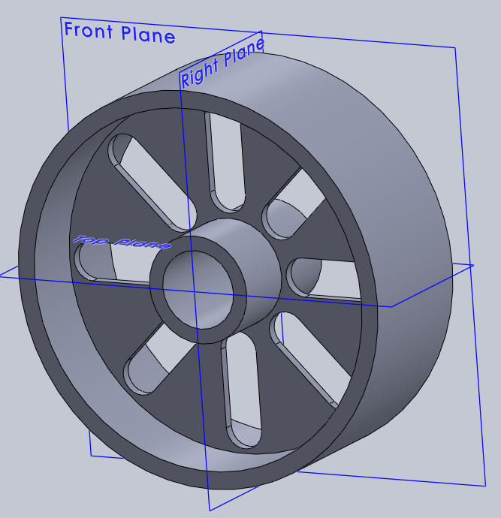

The chases was created with extrude and then the cut holes were mirrored.

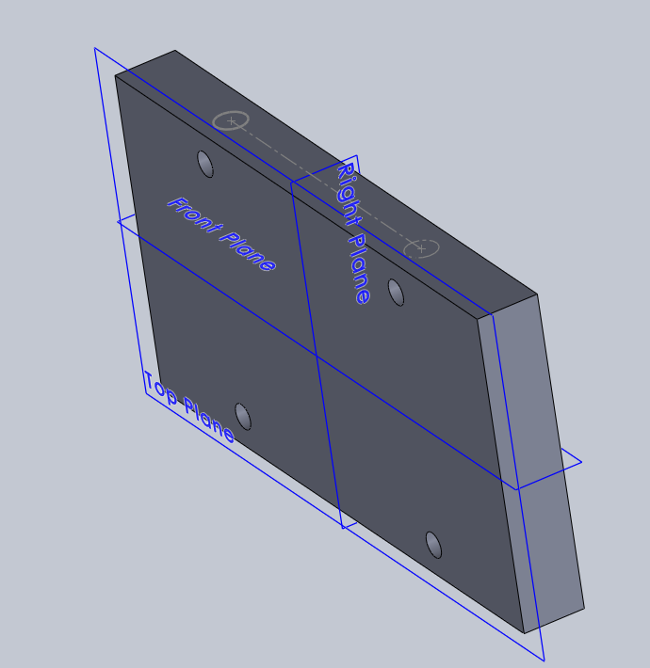

The wheel suspension was created using sweep feature.

